Commerce IdeaBank

User Guide

Table of Contents

All Users

Create a User

Login

Submit an Idea

Edit an Idea

View Your Ideas

View an Idea

Admins

Delete a Project

Archive a Project

View Archived Projects

Create School

Edit School

Assign Ambassador

Change User Permission

Assign Project

Change Project Status

Ambassador

Change Project Status

Create a User:

To create a user, from the homepage, click the “Register” button

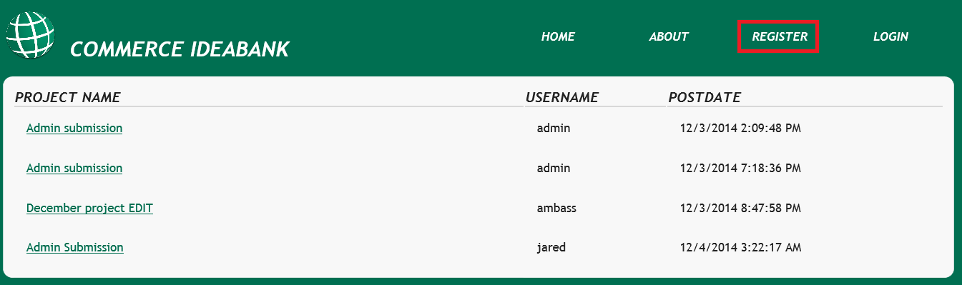

Enter your desired credentials, and click the “Register” button

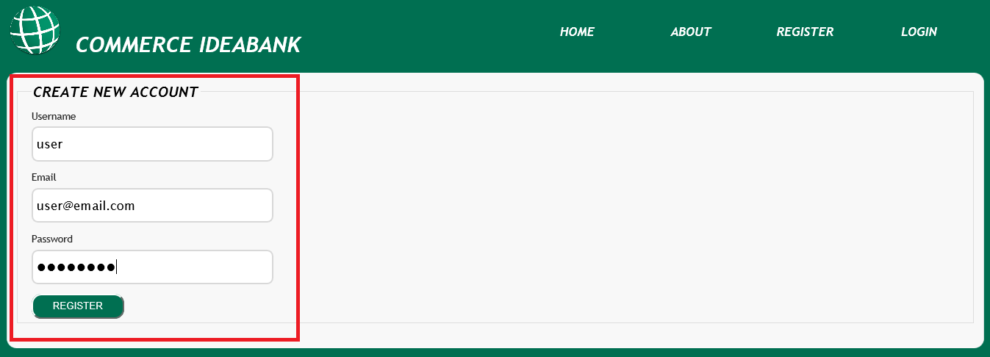

You have now successfully created a user with Contributor permissions, if you need higher permissions, contact your administrator.

Login

To Login, click the “Login” button

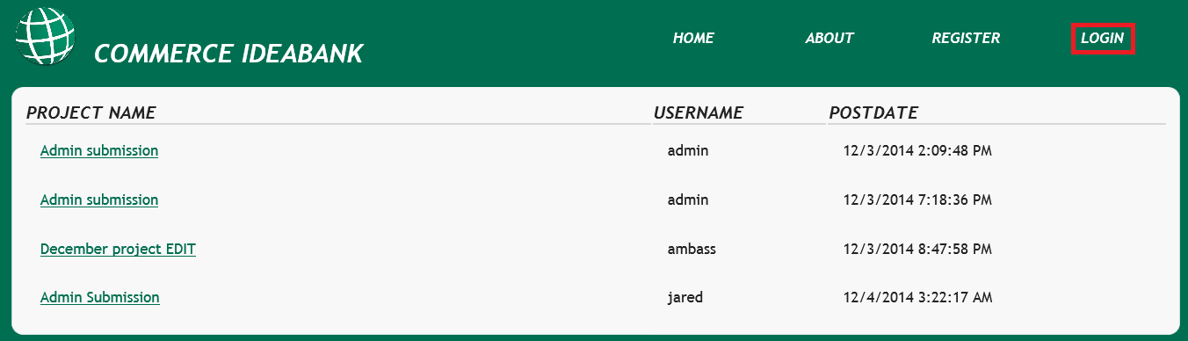

Enter your credentials and press the “Login” button

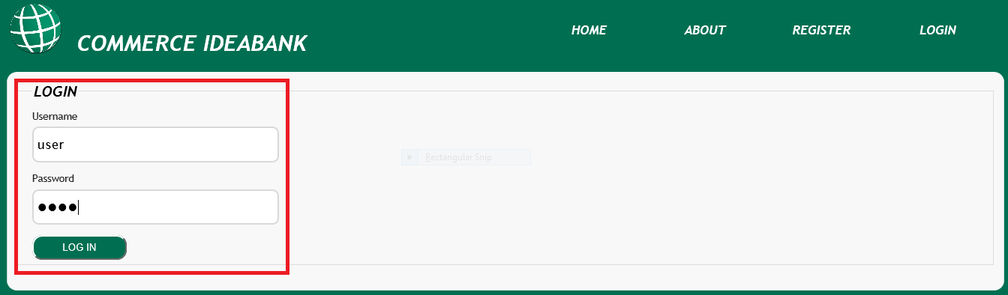

You are now logged in, to confirm this, you will notice a few changes on your homepage. A greeting that includes your username, and some new options in the navigation bar.

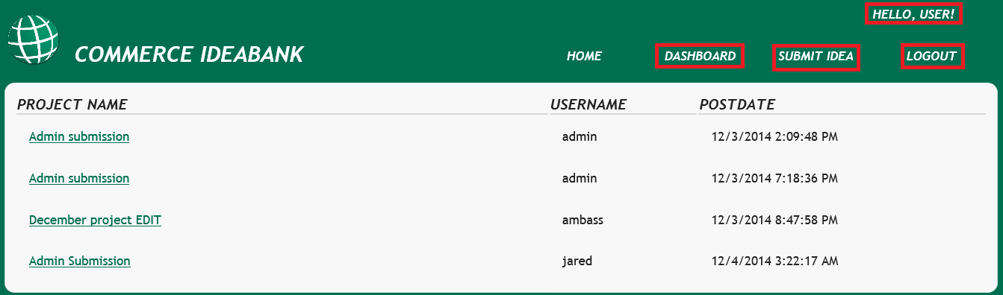

Submitting an Idea

Click the “Submit Idea” Button

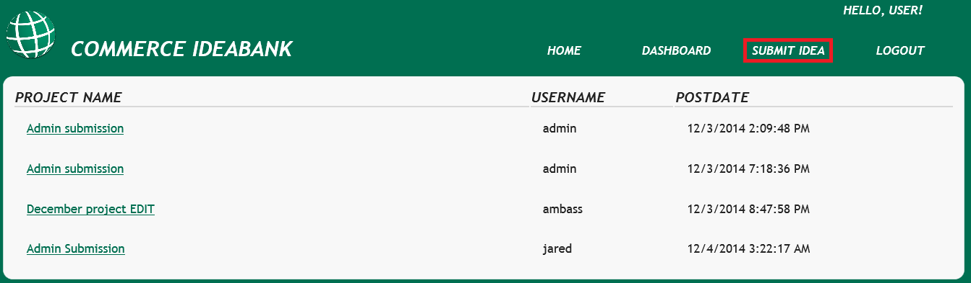

Enter the details of your idea and click the “Contribute” button

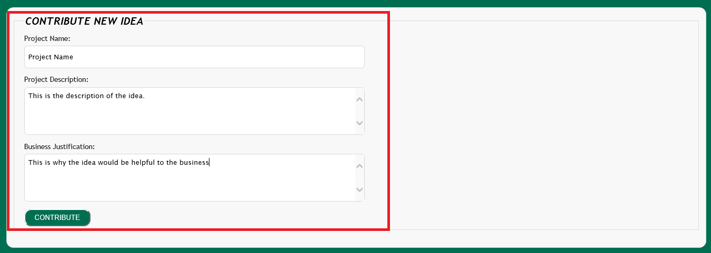

If your submission is successful, it will show up on the homepage, the description will be displayed when the idea is hovered over.

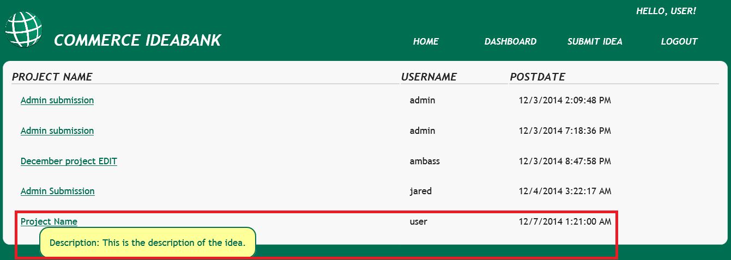

Edit an Idea

Select your idea from the homepage

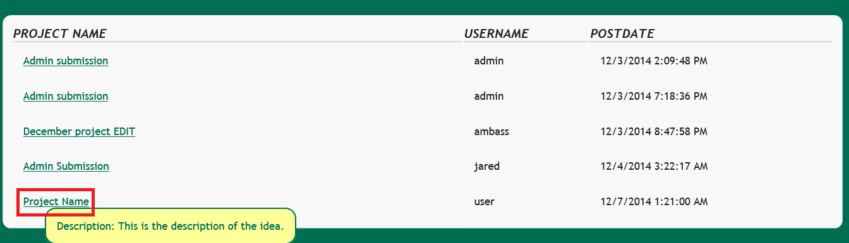

Click the “Edit” button

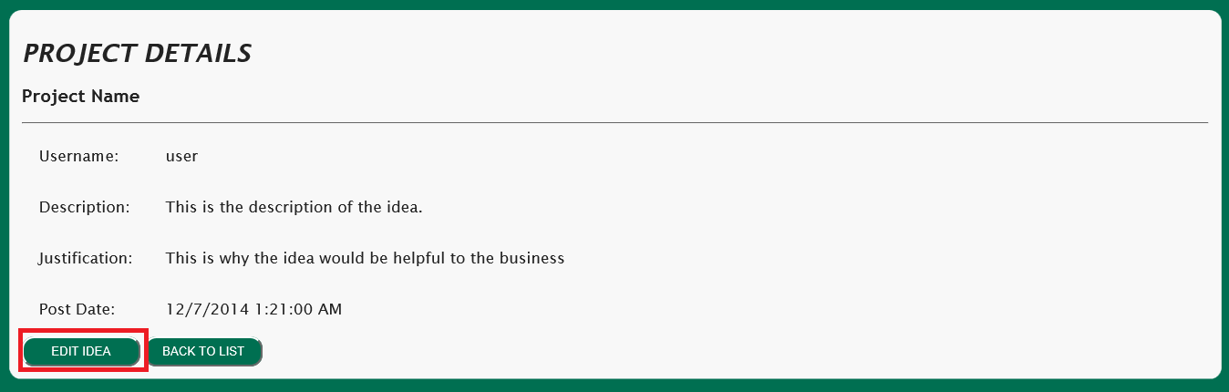

Make desired edits and click the “Save” button

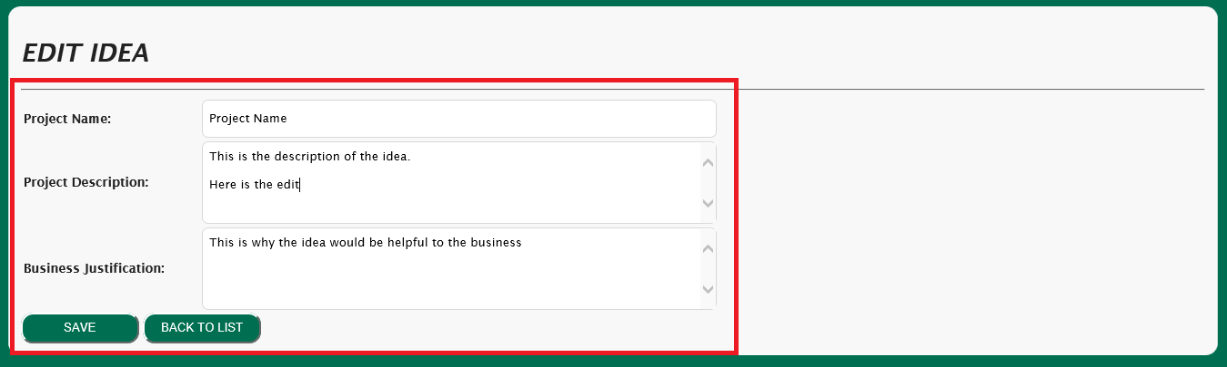

Your edit should now be visible

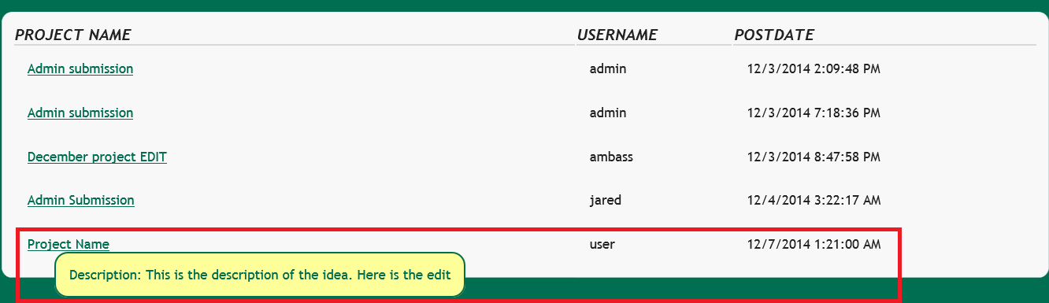

View Your Ideas

Click the “Dashboard” button from the home page



Click the “My Ideas” button

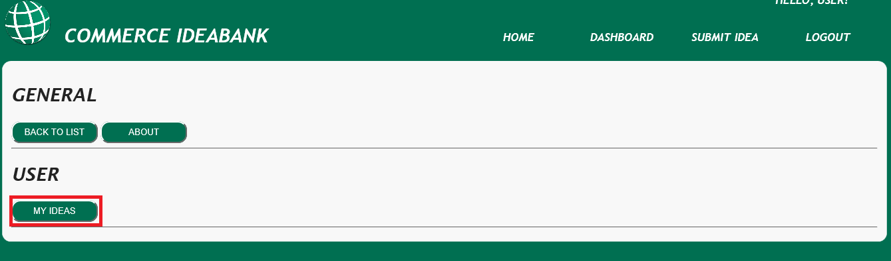

Now only your projects should be displayed, to get back to the full list, click the home button

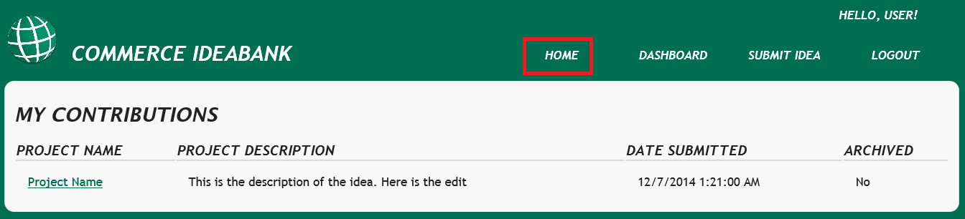

View an Idea

To view an Idea, if you aren’t on the homepage, just click the Home button.



You can then click on the name of any idea to view it.

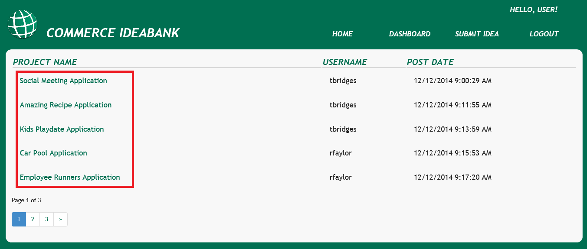

You should now be viewing an idea

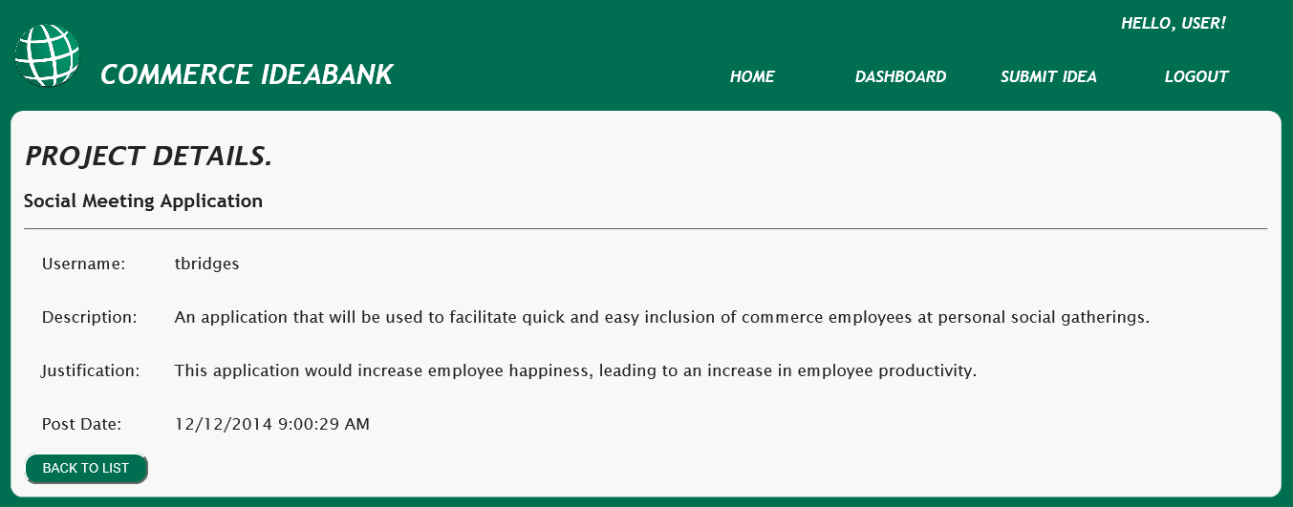

Delete a Project

From the home page, click the title of a project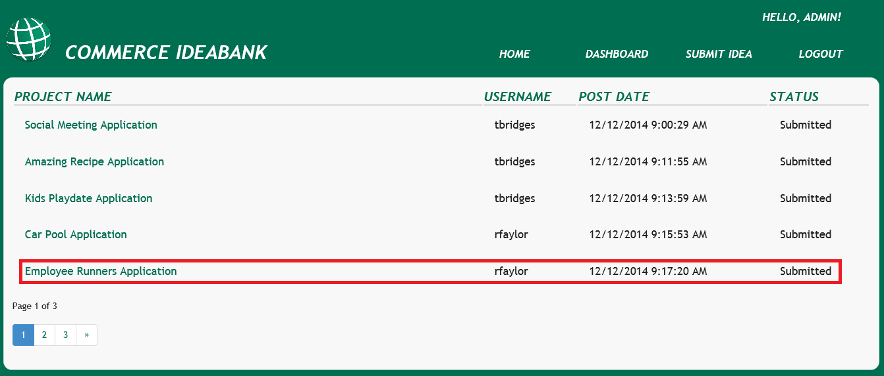

Then click the Delete button

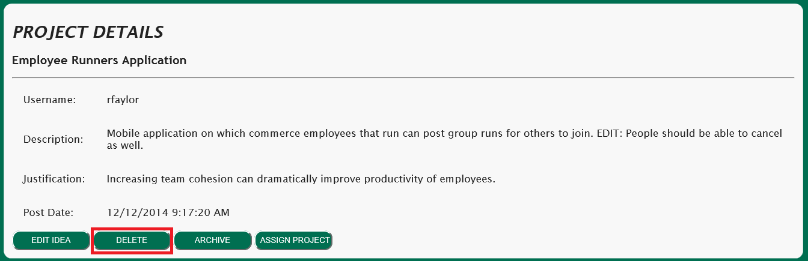

Click delete once more to confirm the delete action

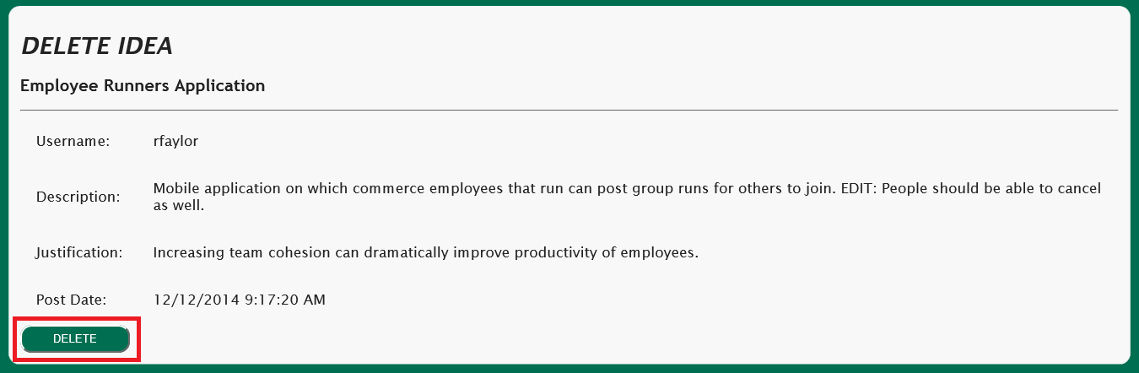

The Project is now deleted.

Archive a Project

From the home screen, click the name of the project you wish to archive

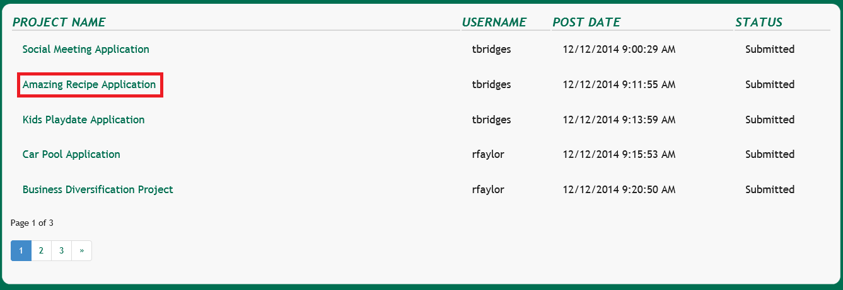

Click the Archive button

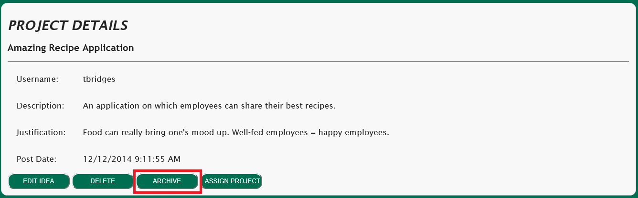

To confirm, press the archive button one more time

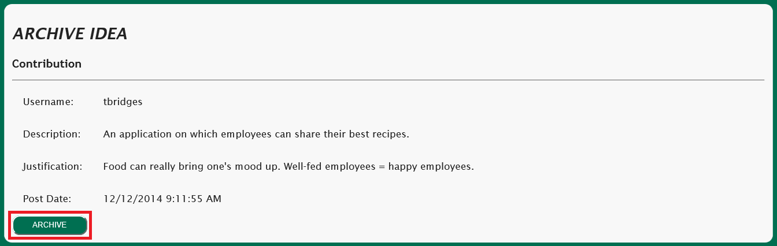

The project is now archived.

View Archived Projects

From anywhere on the site, click the Dashboard button



Click “Archived Ideas”

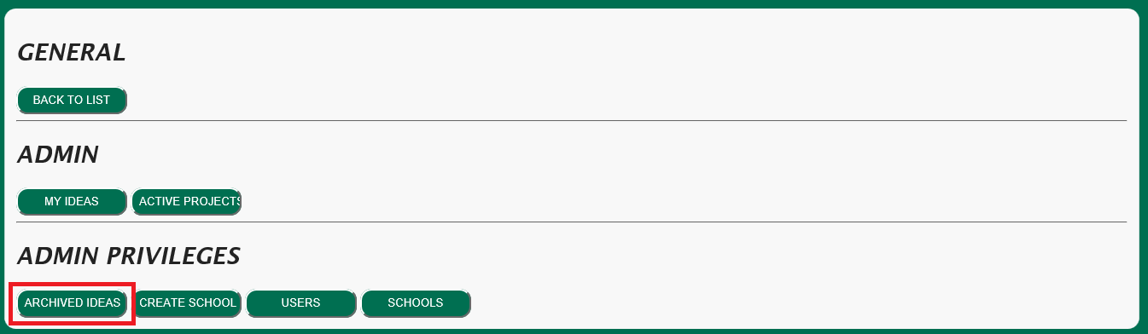

You are now viewing Archived Projects

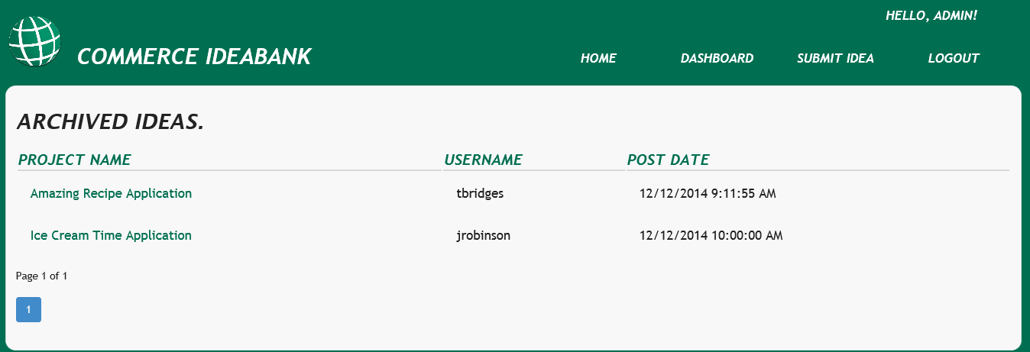

Create a School

From anywhere, Click the dashboard button



Click the Create School button

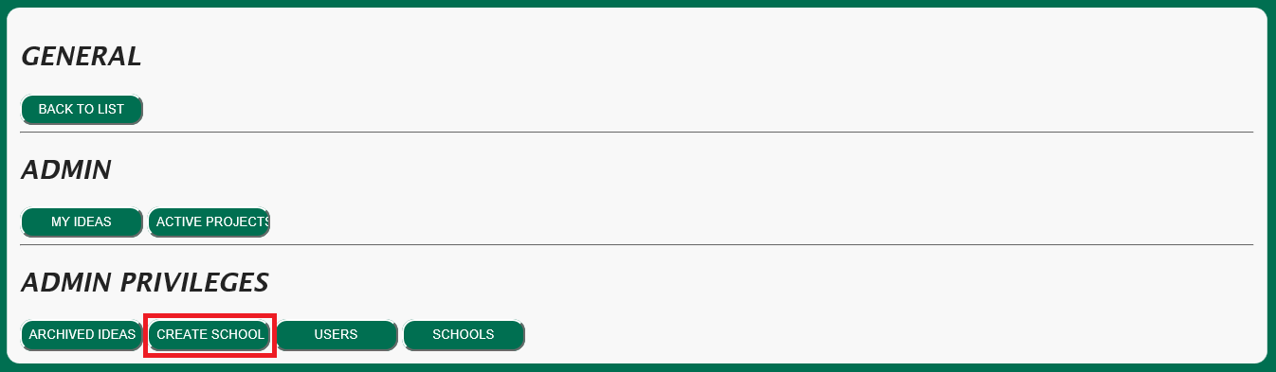

Enter the information in to the corresponding schools and click the Add School button

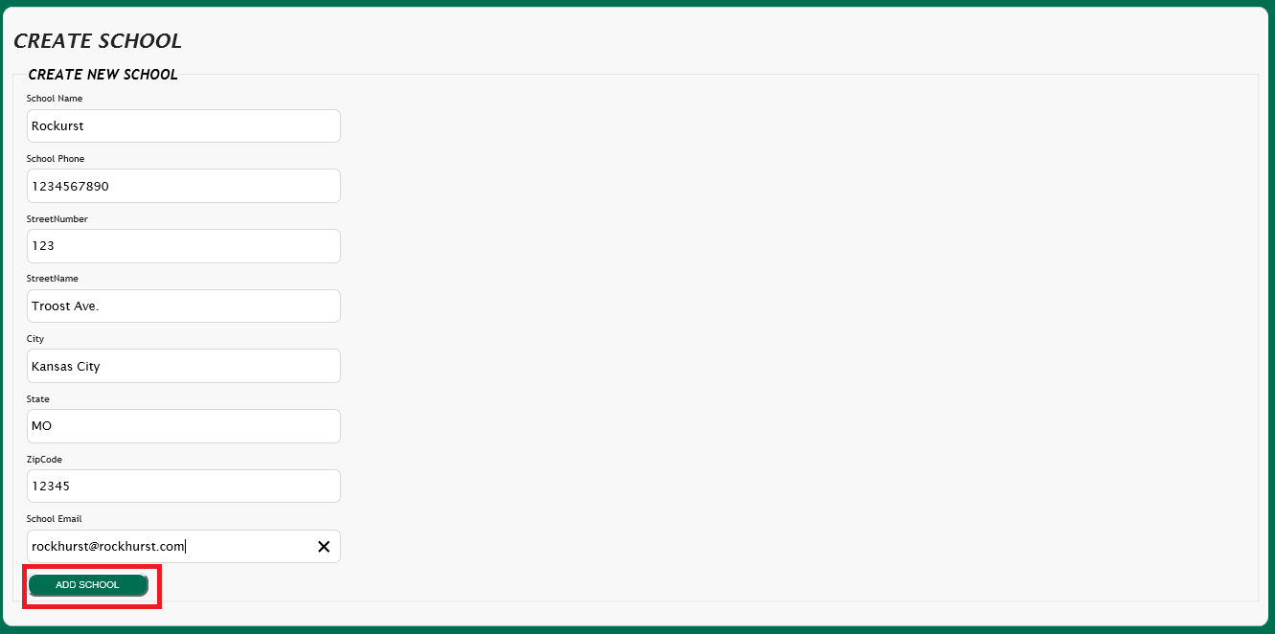

You have now added a new school.

Edit School

From anywhere, click the Dashboard button



Click the Schools Button

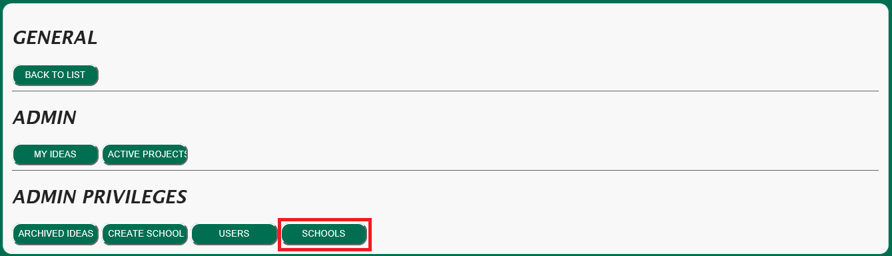

Click the school you wish to edit

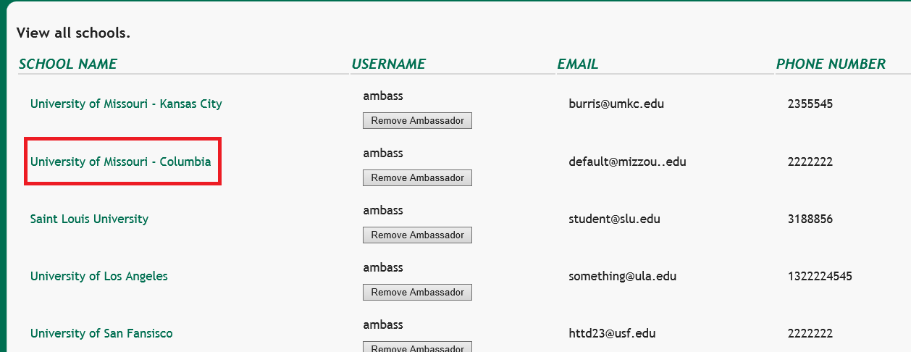

Click the Edit button

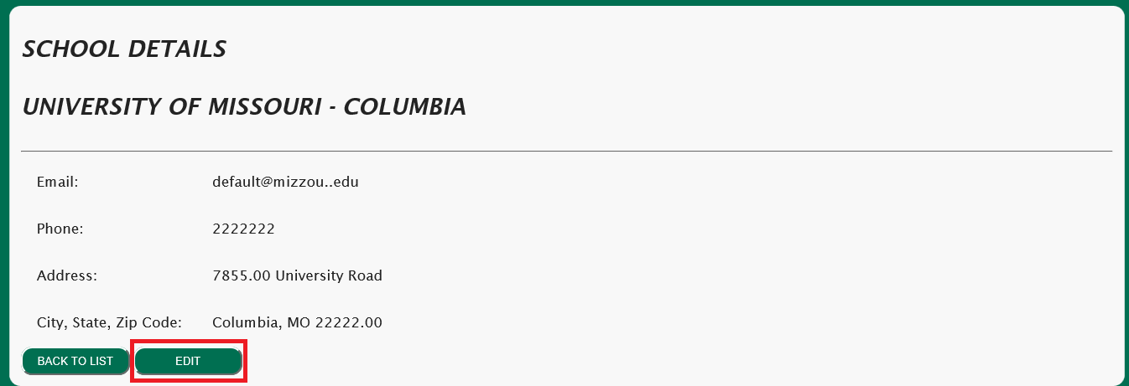

Make your edit and click the save button

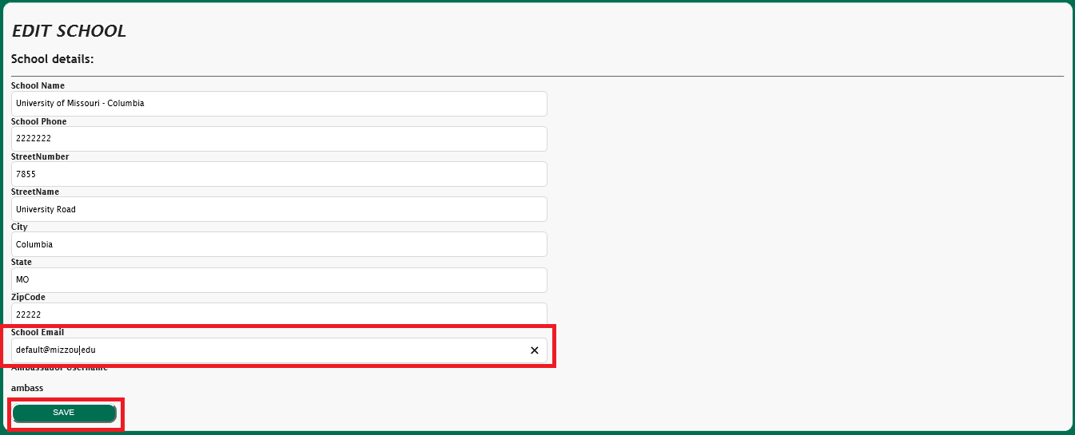

The school has been edited

Assign Ambassador

Click the Dashboard button



Click the Schools button



Click the Add Ambassador button

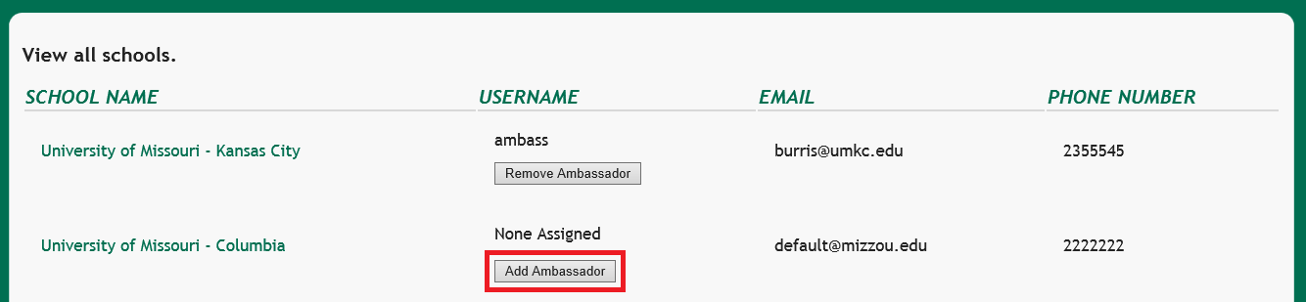

Select the ambassador to add from the dropdown menu and click the assign button.

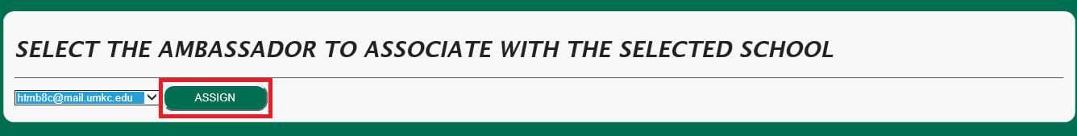

The ambassador is now assigned to that school

Change User Permission

Click the Dashboard button



Click the Users button

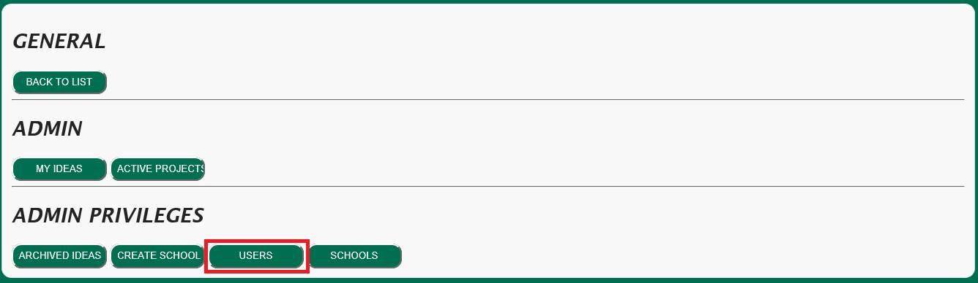

Change the permissions for the user and click the Update Role button

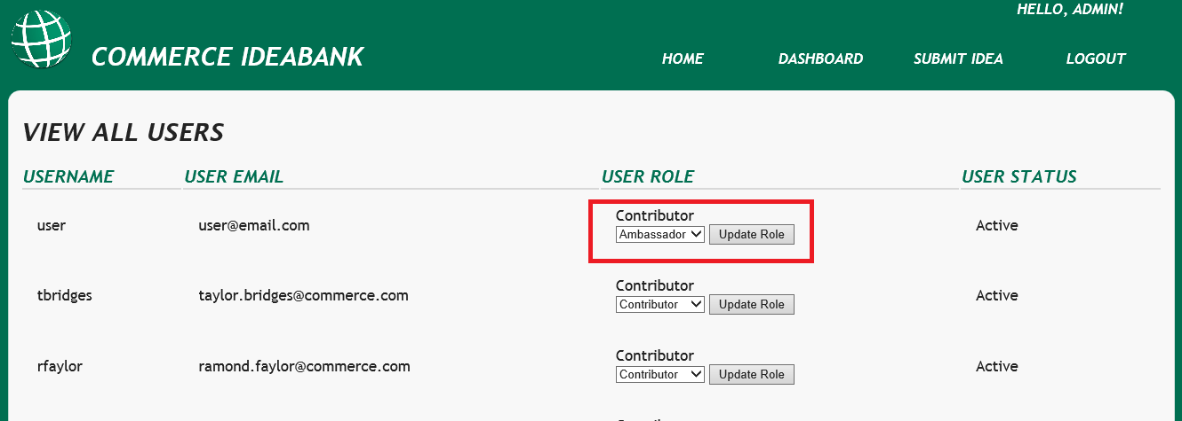

The user role is now updated

Assign Project

Click the name of a project from the homepage

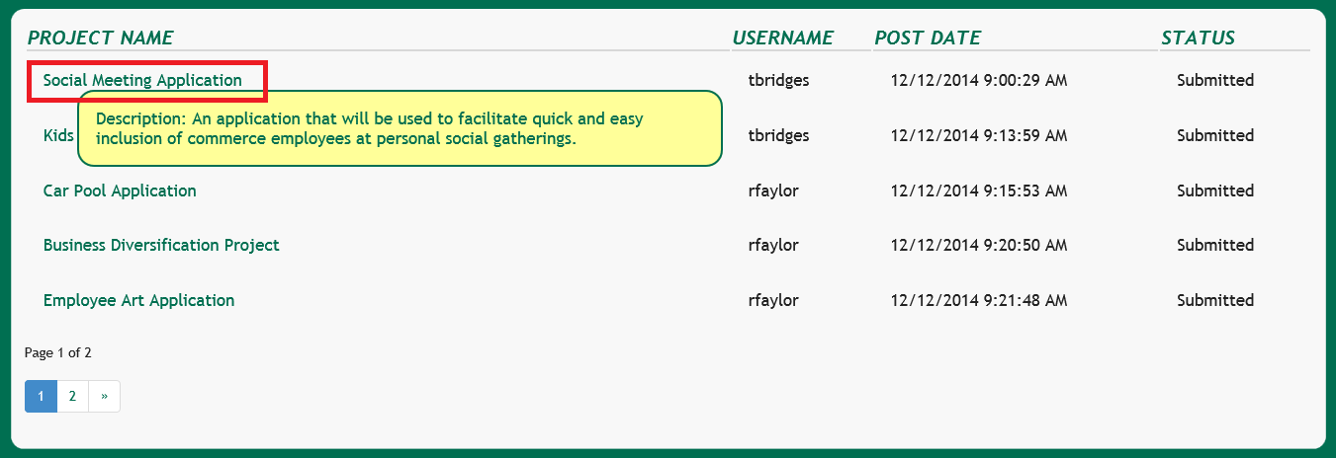

Click the Assign Project button

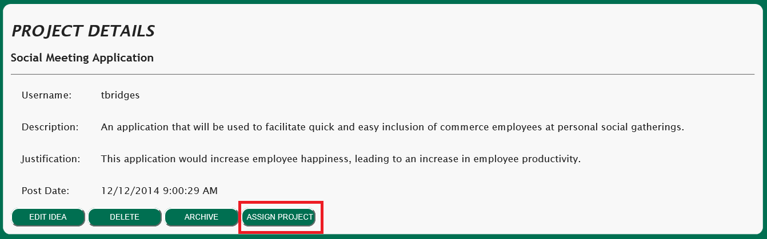

Select the school you wish to assign the project to and click the Assign button

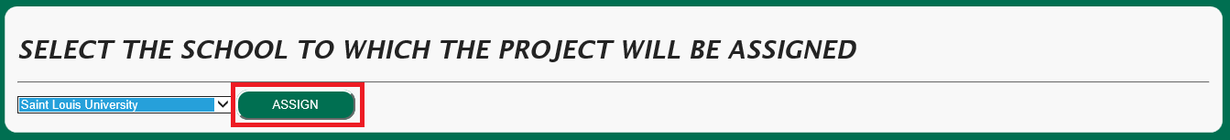

The project is now assigned

Change Project Status

Click the Dashboard Button

Click the Active Projects button

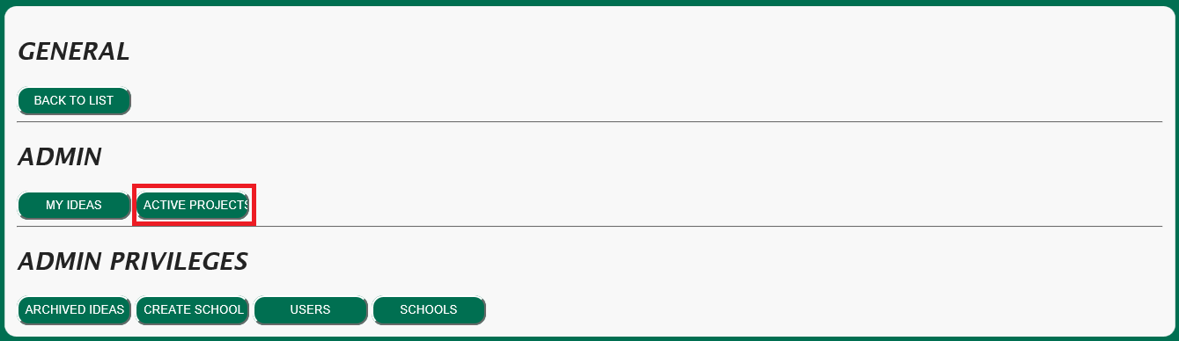

Change the status of the project and click the Update button

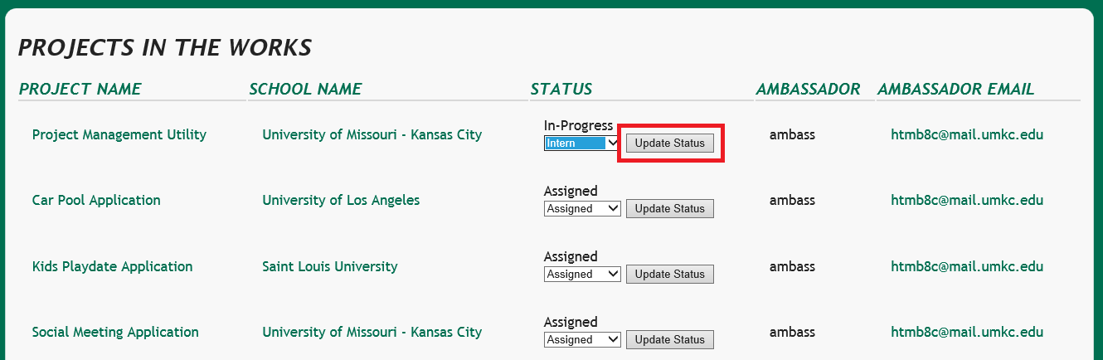

The project status is now updated

Ambassador – Change Project Status

Click the Dashboard button



Click the Active Projects button

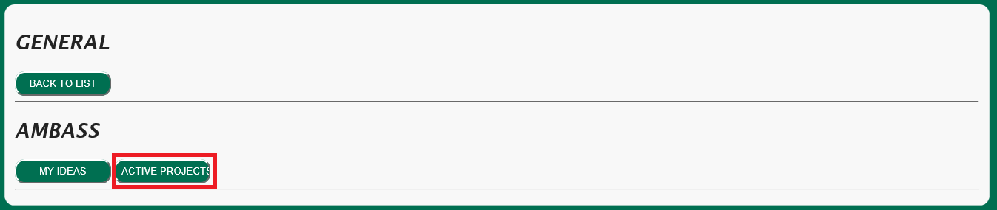

Update the status of the project and click the Update Status button

